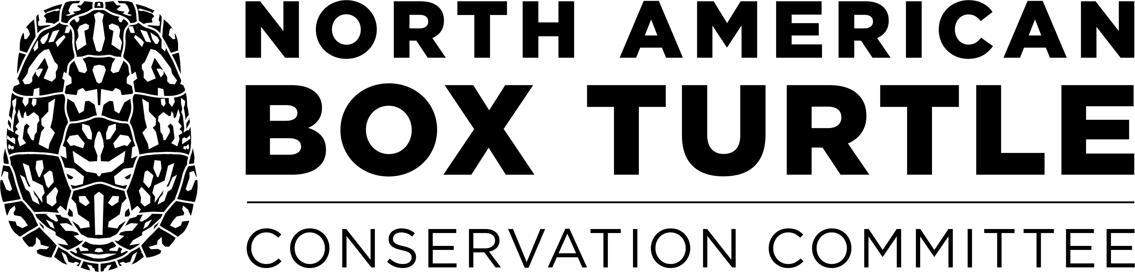

Lucille F. Stickel Box Turtle Research Award
Application for Financial Support for 2024

Projects that will be funded are limited to the following categories:
natural history, ecology, conservation, genetics, reproduction, and epidemiology

A. PROJECT TITLE

B. PRINCIPAL INVESTIGATOR
1. Name and Title
2. Institutional address
3. Phone, FAX, E-mail

C. SUMMARY
1. Total project budget
2. Total requested from Lucille F. Stickel Award fund
3 Starting date (even if the project is underway)
4. Ending date

D. OVERVIEW (not to exceed 250 words)
Describe the project, the project goals and hypotheses being tested (if any).

E. CONSERVATION (not to exceed 250 words)
Describe how your project will aid the conservation or well-being of box turtle populations.

F. METHODS (not to exceed 750 words)
Describe the project methods, the proposed timeline, study area, and partnerships (specify roles of all partners).

G. OTHER INFORMATION
1. How and when will the results of this project be disseminated?
2. If this is a multi-year project, what is the funding strategy for subsequent years?
3. Have all the necessary permits been obtained for the project? If yes, attach copies of permits to this proposal. If no, please explain.

H. BUDGET
1. Detailed total project budget
2. Other funding sources (identify projected as well as actual funders)

I. ATTACHMENTS
1. Curriculum vitae(s) of Principal Investigator(s)
2. Copies of appropriate permits
3. Letter of support (if applicable)

J. APPLICATION PROCEDURE AND DEADLINE
Send electronic copy as a Microsoft Word attachment to nabtconservation@gmail.com by 5pm ET on February 5, 2024. Applications will be reviewed by members of the Box Turtle Conservation Committee. Successful applicants will be notified by email by March 4, 2024. Project titles and names of authors will be posted at boxturtleconservation.org.

K. CONDITIONS
If funding is provided, we require that awardees recognize the North American Box Turtle Conservation Committee and the Lucille F. Stickel Box Turtle Research Award in all resulting publications and report. Copies of all publications and reports should be sent to the Committee (via John Groves). Progress reports for projects lasting more than one year must be submitted on the anniversary of receipt of funding. We also request that 3-5 images be provided for informational purposes, and for possible distribution to websites or publications. Progress reports and images should be sent to nabtconservation@gmail.com.

Please enter your name below if you agree to these conditions:

I, ___________________________________, agree to these conditions.

